**“Community Perception on Natural Resources Preservation**

**of Molocaboc Island”**

A Research Paper Presented to

The Faculty of the College of Business and Management

State University Of Northern Negros

Brgy. Rizal, Sagay City, Negros Occidental

In Partial Fulfillment

of the Requirement for the Degree

Bachelor of Science in Tourism Management

Rizza Mae V. Lobaton

Julie Ann N. Antisoda

Rhea Jane M. Veloso

Samantha Nichole T. Borres

Mary Grace B. Patron

Karl Patrick Rosega

January 20, 2024

**THESIS APPROVAL SHEET**

This Undergraduate Thesis, titled **“OPPORTUNITIES IN TOURISM TRANSPORT SERVICES IN BARANGAY OLD SAGAY, SAGAY CITY, NEGROS OCCIDENTAL”**, prepared and submitted by **APRIL ROSE A. BATOBALONOS, EMELYN L. MAGLASANG, LOVELY GIRL C. ABUAN, YNAH MARIZ E. CASTROVERDE, CHERELYN S. OGAHAYON AND JEAN V. TOMATE** in partial fulfillment of the requirements for the degree **BACHELOR OF SCIENCE TOURISM MANAGEMENT**, has been examined and recommended for approval.

**XXXXXXXXXXXXXXXXXXX**

Adviser

**THESIS COMMITTEE**

**KRISTIN IRIS G. ESTORES, PhD ELYN MAE P. ALCANTARA, MBA-HTM**

Member – Research Coordinator Member – Program Head

**VERGEL S. MANIPOL, CPA, PhD**  **KRISTINE T. SOBERANO, PhD**

Chairman – Dean Member – Research Director

**PANEL OF EXAMINEES**

**KRISTIN IRIS G. ESTORES, PhD ELYN MAE P. ALCANTARA, MBA-HTM**

Member – Research Coordinator Member – Program Head

**VERGEL S. MANIPOL, CPA, PhD**  **KRISTINE T. SOBERANO, PhD**

Chairman – Dean Member – Research Director

**ACCEPTED AND APPROVED** in partial fulfillment of the requirements for the degree **Bachelor of Science in Tourism Management.**

Date of Proposal Defense: Month, Date, Year

Date of Final Defense: Month, Date, Year

**JOCELYN D. BANTIGUE, Ph.D.**

VP- Academic Affairs

**ACKNOWLEDGEMENT**

First and foremost, we offer our heartfelt praises and gratitude to God for His blessings, guidance, and unwavering presence throughout our research journey. His divine wisdom and grace have provided us with the strength, inspiration, and perseverance needed to complete this research. We would also like to express our deep gratitude to our research adviser, Ms. Rose Ann A. Villarias, MBA-HTM, and to our research instructor Dr. Kristin Iris G. Estores, Ph.D. Their guidance, expertise, and unwavering support have been instrumental in shaping the direction and quality of this research. We extend our sincere appreciation to our esteemed panel members, Dr. Richel P. Alob, PhD, DBA, Dr. Rechie B. Pabelona, PhD, Ms. Elyn Mae P. Alcantara MBA-HTM, Ms. Lea Mae K. Calimpong, LPT, MAEd, Mr. Ronie John V Casi, MS-HM, whose insightful feedback and constructive criticisms have significantly improved the quality of our work. Your expertise and dedication to upholding academic excellence have not only shaped this research but also our growth as budding researchers.

Heartfelt appreciation is also extended to the participants who generously dedicated their time and shared their insights, without whom this study would not have been possible. Their contributions have enriched our findings and added depth to the research. More so, we would like to acknowledge the Northern Negros State College of Science and Technology for providing the necessary resources and facilities that supported this research endeavor. Additionally, we are deeply indebted to our family and friends for their unwavering encouragement, understanding, and patience throughout this challenging journey. Their love, support, and belief in us have been a constant source of motivation. Lastly, we would like to express our sincere appreciation to each of the individuals who have provided assistance, advice, and encouragement along the way. Their contributions, whether big or small, have played a significant role in the completion of this research. We would like to thank everyone involved for being a part of this journey and for the invaluable contributions extended towards the success of this research journey.

**TABLE OF CONTENTS**

Page

TITLE PAGE i

APPROVAL SHEET ii

ACKNOWLEDGMENT iii

TABLE OF CONTENTS iv

LIST OF FIGURES v

ABSTRACT vi

INTRODUCTION 1

METHODS 4

Research Design 4

Respondents of the study 4

Data Gathering Instrument 5

Validity 5

Reliability 5

Data Gathering Procedure 7

Ethical Considerations 8

RESULTS AND DISCUSSION 10

CONCLUSION & RECOMMENDATION 15

APPENDICES 15

Appendix A: Research Questionnaire 17

Appendix B: OKFIQ 19

Appendix C: Survey Instrument Validation Rating Scale 21

Appendix D: Summary Result of the Validation 22

REFERENCES 23

**LIST OF FIGURES**

Figure Page

1 Framework of the Study 3

**ABSTRACT**

This study explores the community perceptions on natural resource preservation in Molocaboc Island, Sagay City, Negros Occidental, with a focus on its potential for community-based tourism. Through qualitative research, the study highlights the benefits, challenges, and interconnected factors related to conservation and sustainability, livelihood, and ecosystem interdependence. Key findings reveal that natural resources such as mangroves and coral reefs play a crucial role in the community’s economic stability, environmental protection, and cultural heritage. Efforts such as mangrove reforestation and coastal cleanups demonstrate the community’s commitment to sustainability. However, challenges such as illegal fishing practices, financial constraints, and limited community participation hinder the effective implementation of preservation strategies. The study underscores the importance of fostering collaboration, integrating local knowledge into policy-making, and addressing systemic barriers to achieve sustainable natural resource management. By aligning community values with conservation efforts, Molocaboc Island holds the potential to serve as a model for sustainable development and environmental stewardship.

Keywords: *Community perceptions, Natural resource preservation, Molocaboc Island, Community-based tourism, Conservation and sustainability, Livelihood, Ecosystem interdependence, Mangrove reforestation, Coral reefs, Environmental protection, Economic stability, Cultural heritage, Illegal fishing, Financial constraints, Sustainable development, Environmental stewardship*

**Introduction**

Natural resources preservation is a crucial part especially in this ever-changing climate and mankind’s behavior. Based on the UNESCO (2024), biodiversity is currently being lost at up to 1,000 times the natural rate. Some scientists are now referring to the crisis as the ‘Earth’s sixth mass extinction’, comparable to the last great extinction crisis 65 million years ago. These extinctions are irreversible and pose a serious threat to our health and wellbeing. Designation and management of protected areas is the cornerstone of biodiversity conservation. However, despite an increase in the total number of protected areas in the world, biodiversity continues to decline. Climate change challenges require the conservation of natural resources. Global population growth increases demand for timber, minerals, and fossil fuels. However, these resources' extraction and depletion seriously affect the environment. Conservation of natural resources and combating climate change require reforestation. By absorbing carbon dioxide from the atmosphere, trees act as carbon sinks. Planting and restoring forests can conserve biodiversity, prevent soil erosion, and sequester carbon (Lu & Wang, 2023).

In the ASEAN setting, some studies present several important conclusions regarding the challenges and implications of displacing populations for environmental preservation projects. It is noted that sustainable development efforts, particularly those aimed at preserving natural resources, have gained significant momentum globally. However, the preservation of natural resources often leads to the displacement of certain populations. This displacement can create various challenges that need to be addressed promptly to ensure successful resettlement. It is drawn that the necessity of timely intervention to tackle the challenges arising from displacement (Dar & Kumar, 2022).

The same study has conducted in the Bulusan, Philippines, the investigation focuses on resource protection strategies in Bulusan Volcano Natural Park (BVNP) yielded several important conclusions regarding sustainable ecotourism and conservation efforts. BVNP is actively engaged in conserving the environment while promoting socio-economic development for the local community. This act of preservation is facilitated through the leadership of civil society organizations like AGAP Bulusan, Inc., which plays a vital role in managing conservation efforts effectively. Furthermore, the evaluation of resource protection strategies by visitors indicates a positive correlation with their overall experience in the park. It shows that the visitors generally found the strategies for social and environmental conservation to be effective (Rebuya, 2020).

In some studies related on Negros, it is identified that local communities utilize 113 different species of plants for various purposes, including food (26%), ornamental (24%), herbal or medicinal (19%), construction (12%), commercial (9%), charcoal and fuel wood (8%), and craft (3%). This signifies the important role that local biodiversity plays in the livelihoods of these communities. Through investigating the management of NNNP using the Management Effectiveness Tracking Tool (METT). It found that the "context" and "planning" components received ratings of 64% and 53.8%, respectively, indicating strengths in these areas but also highlighting the need for improvement in overall management effectiveness (Dechimo & Buot, 2023).

The Molocaboc Island is a Barangay of Sagay City, Negros Occidental. A unique marine reserve, because there are people residing on the island.It is a "home to fisher folk where big jars, mangrove reforestation and a miracle hole “amatong” fishing are found." (Negros Occidental Tourism).At the moment, this humble paradise is closed for tourism. The Local Government of Sagay City in cooperation of the Department of Education-Division of Sagay City is preparing the people living at the island for tourism as it is yet to be furnished for safety, accomodations, and maintenance of the paradise.

While it is true that there may be studies on the natural resources of Molocaboc Island and potential tourism initiatives, still, there seems to be a lack of research specifically focusing on the community's perspectives on these issues. This is crucial as their insights are essential for the successful implementation and sustainability of any community-based tourism endeavors in the said area of study. This study address the in-depth understanding of community perceptions. It also includes the exploration of community-driven conservation strategies. More importantly, it will uncover the insufficient analysis of potential benefits and challenges that have not been addressed to other studies.

**Purpose of the Study**

This study aims to identify the insight of the community with regards to the Natural Resources Preservation of Molocaboc Island and its Potential for Community-Based Tourism Initiatives. The study will investigate the potential experiences of the people in the said locality. Additionally, the people’s insights will also be part of the study’s scope. Lastly, the suggestions of the people is also helpful for discovering other potential ideas about natural resources preservation and community-based tourism initiatives.

**Objectives**

This study aims to identify the benefits of implementing economic, environmental and socio-cultural practices in Molocaboc Island, and to assess what is needed to be done to address the challenges of Natural Resources Preservation in Molocaboc Island.

**Conceptual Framework**

The paper addresses natural resource management practices in Molocaboc Island which are adopted and still remained to adapt especially for the management of land, watershed, forest and other plants, and animal lives. This is followed by inclusion of the traditional and present - day practice systems of natural resource management which helps in the identification of factors and processes contributing to resource degradation. Lessons from past systems and successful experiences of new initiatives and practices of natural resources management are discussed to suggest possible approaches to rebuilding communities’ natural assets. The crucial role of natural asset building in sustainable development by conserving, regenerating, upgrading, and equitably harnessing natural resources, particularly forests, pastures, and their links with crop lands stems from the contributions of these resources towards enhancing the qualitative livelihood.

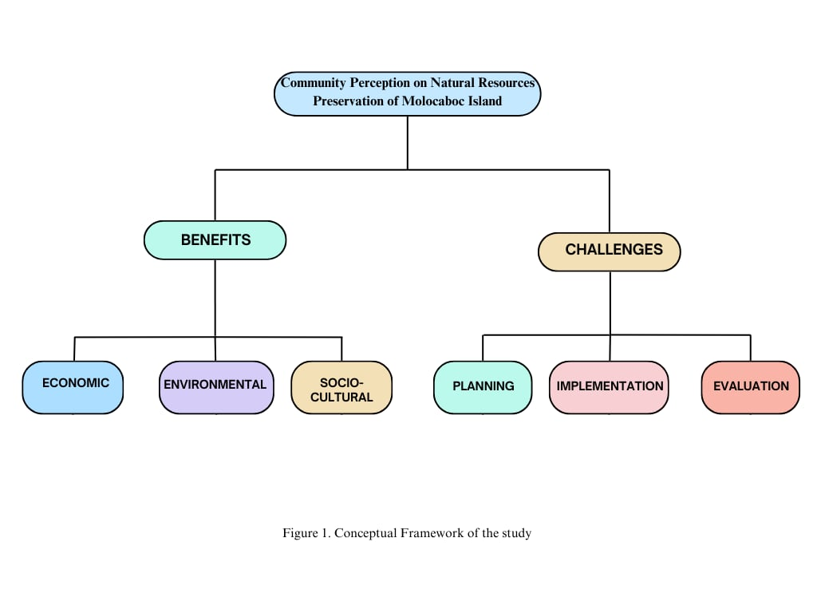

Figure 1. Conceptual Framework of the Study

**Methodology**

This methodology outlines a qualitative research framework designed to explore community perceptions concerning the challenges, opportunities, and benefits of natural resource preservation in Molocaboc Island, Sagay City. The research aims to capture the intricate dynamics of local viewpoints regarding natural resources while emphasizing community engagement and sustainable practices.

**Research Design**

A qualitative research design will be implemented to provide a comprehensive understanding of community perceptions. ​This approach allows for the exploration of specific contexts and experiences of residents in relation to the natural resources on Molocaboc Island (Yin, 2014; Stake, 1995; Creswell, 2013).​

**Research Participant**

The participants of this study will be the community leaders who are currently residing in Molocaboc Island. The research participants will be asked about their challenges and benefits they get to the preservation of natural resources of the said island. For this reason, the research will employ purposive sampling where the selected 5 participants will be sharing their experiences and observations to the community-based tourism initiatives of the area. To specify the identification of the participants, they should have resided at the said island in almost 5 years, new settlers are not counted. More importantly, they must be 18 years old above and able to share their experiences in the island, as well as voluntarily agree to participate in the study as they providing honest responses in being part of the community.

The researchers choose 5 participants to reach saturation of data. As it is noted, the number of participants is guided by different methodological approaches of qualitative inquiry. In this way, it could be 5-10 participants depending upon the nature of the study and the information to be collected (Gentles et al., 2015).

Prior to that dispense, qualitative inquiry typically focuses in depth on relatively small numbers of participants (e.g., 5–30) who are selected purposefully. The researcher goes to the experts of the phenomena under study—the people who are experiencing it (Patton, 2017).

Coupled with that thought, it was noted by Janashak Cadena (2019) that the main purpose of qualitative research is to understand and interpret social interactions as mentioned in this paper, where the researcher wishes to explore a perplexing problem, providing a detailed understanding of a central phenomenon and seeking to appreciate the participants' experiences.

Correspondingly, a qualitative inquiry typically focuses in depth on relatively small numbers of participants, generally ranging from 5 to 10, who are selected purposefully to provide rich, detailed insights into their experiences, rather than relying on larger sample sizes (Coyle & Tickoo, 2017).

Likely enough, in a qualitative research about participants' perspectives on the feasibility of a novel, intensive, task-specific intervention for individuals with chronic stroke, the study provides a unique opportunity for patients to express opinions and provide valuable insight on intervention processes (Merlo et al., 2013).

More importantly, in the research of Kapania et al. (2024) that aimed to explore their perspectives on using large language models as substitutes for human participants in qualitative research, highlighting the same process, wherein the research involved interviews with 19 qualitative researchers, not limited to 5-10 participants.

**Research Instrument**

This research will utilize an interview guide that contained the major question in observing the natural resources preservation of the said island. The participants are free to open in-depth answers pertaining to their experiences, insights, as well as their suggestions to the Molocaboc Island pertaining to the community-based tourism initiatives.

**Validation and Reliability of the Research Instrument**

Precept upon this study, as a researcher, the primary concern was how to persuade the readers to believe the results or findings of this study. In any qualitative research, for issues of trustworthiness, four issues of trustworthiness demand attention: credibility, transferability, dependability, and conformability as researcher, they will discuss them one by one (Shenton, 2004). To address credibility, the researcher employed techniques that help to generate facts and information needed in the study. The researcher conducted an in-depth interview with interview guide to gather substantial information from the chosen participants whose parents are working abroad.

The extent to which the outcomes could be validated by others. There are several methods for increasing confirmability. Throughout the data interpretation, the researchers can administer the techniques for checking and rechecking the data. Another set of researchers can act as a "mediator" for the finding to, and the process can be documented. The researchers might actively search and explain negative examples that contradict previous findings. Following the research, a data audit can be conducted, which reviews the data collecting and analysis techniques and provides judgments regarding the potential for fraud and bias.

**Sampling Strategy**

​A purposive sampling technique will be employed to select participants who possess relevant knowledge about the community's relationship with natural resources.​ This technique is particularly effective for qualitative research as it allows researchers to select individuals who can provide deep insights into specific phenomena based on their experiences and backgrounds (Palinkas et al., 2015). For this study, approximately 5 - 10 participants will be identified, ensuring a diverse representation across different demographics to capture a holistic understanding of community perceptions.

**-**Overview of Purposive Sampling Technique

Purposive sampling, also known as judgmental sampling, is a non-probability sampling technique where researchers selectively choose participants based on specific characteristics or qualities they possess that are relevant to the research study. This method is widely used in qualitative research since it enables researchers to gather detailed and insightful data from individuals who have direct experience or knowledge about the phenomena being investigated.

**-**Purpose and Advantages

The primary aim of purposive sampling is to obtain rich data from individuals who are likely to provide relevant insights due to their particular knowledge or experiences related to the research topic. This technique is particularly effective when the researcher is interested in understanding nuanced perspectives within a defined community, as it allows for focused inquiry that is closely aligned with the study’s objectives.

* Depth of Insights: Participants can offer profound insights grounded in their experiences.
* Targeted Selection: Researchers can identify individuals that meet specific inclusion criteria critical for the study.
* Diverse Representation: By intentionally selecting participants from various demographics, researchers can capture a more comprehensive view of the community's perceptions about natural resources.

**-**Implementation Steps

When employing purposive sampling for a study, researchers typically follow several key steps:

* Define the Research Problem: Clearly articulate the issues or questions the research aims to address, which will guide participant selection.
* Determine the Population: Identify the community of interest and the characteristics that participants must possess to be included in the study.
* Select Participants: Based on the defined criteria, researchers identify a group of individuals, around 5-10 in this case, who are representative of various demographics. This selection is made to ensure diversity and obtain a holistic understanding of community perceptions towards natural resources.
* Data Collection: Utilize appropriate data collection methods such as interviews or focus groups to gather information from the selected participants in an effective manner.
* Analysis: Analyze the collected data to extract themes, patterns, and insights that inform the research questions being explored.

**Data Collection Methods**

Semi-structured interviews will serve as the primary data collection method for this qualitative research. This interview format is particularly beneficial as it allows for open-ended questioning, enabling participants to express their thoughts and feelings in their own words. Additionally, the semi-structured nature of the interviews provides the flexibility to explore nuances in how participants perceive the challenges, opportunities, and benefits associated with natural resource preservation. This method is particularly effective in eliciting rich, detailed accounts that can uncover underlying beliefs and attitudes (Creswell, 2013).

An interview guide will be developed to ensure consistency while allowing for the exploration of emerging topics. The guide will incorporate key themes such as:

Challenges: Participants will discuss the various obstacles they encounter regarding resource management, encompassing issues such as environmental degradation, inadequate policies, and external economic pressures impacting local resources. These challenges may reveal systemic issues that require deeper understanding and intervention (Hennink et al., 2019).

Benefits: Participants will be encouraged to identify and articulate economic benefits related to sustainable practices, including job creation, increased tourism potential, and local revenue generation. Additionally, participants will reflect on socio-cultural benefits, such as enhanced community cohesion and the preservation of cultural identity, as well as environmental benefits resulting from healthier ecosystems and greater biodiversity. Such reflections can provide valuable insights into residents’ motivations for engaging in sustainable practices (Lijun, Ling & Ahmed, Elsadig. (2024).

Interviews will be conducted in a relaxed and comfortable environment to promote honest dialogue. By creating a welcoming atmosphere, participants are more likely to share personal anecdotes and experiences that illuminate their perceptions and emotional connections to natural resources. This setting encourages respondents to not only recount factual information but also to articulate their feelings and narratives, lending depth to the qualitative analysis (Kvale & Brinkmann, 2015).

**Data Analysis**

To interpret the result of the study, the data analysis take a deductive approach. The deductive approach to qualitative data analysis entitled interpreting gathered data according to predetermined framework of the researchers. The researchers will utilize the 3Cs Lichtman analysis: coding, categorizing and identifying concepts (Lichtman, 2013).

​ Reading and re-reading of the interview transcripts with initial coding. We read and re-read each individual interview transcripts until we achieved a generalization of the interview. We assigned words and phrases as a unique descriptive code. Each code symbolically assigned salient, essence-capturing and evocative characteristic for a portion of language based data. Every significant descriptions, ideas was coded regardless whether it was directly related to the research questions or not.

The researcher used preliminary coding to analyze interview transcripts. This was done because all significant statements coded were placed under the same code into broader categories to get a fuller grasp of the data. The core categories were identified in that they captured the central ideas, themes, and understandings that emerged from their own perspectives and experiences relative to the context.

Generating the Concepts (Thematic Insights) we read and re-read the categories or emerging issues until a conceptual structure emerged from the data, which described the essence of the phenomenon. Generating the Eidetic Insights (Concepts) we called out the eidetic insights in light of current related literatures (i.e. CLE integration and instruction) to describe the meaning and essences described by my conversation partners.

​ In data processing, the researchers will be using thematic analysis that will undergo familiarization with the data, gathering initial codes, searching for themes, reviewing themes, defining and naming themes and writing the report of the study (Braun & Clarke, 2012). The data is the primary core of any research study; it is critical to ensure error to be removed.

**Ethical Considerations**

Ethical principles will play a crucial role in guiding the research approach, ensuring that respect and integrity are maintained throughout the entire research process. By upholding ethical standards, the research aims to protect participants' rights and foster trust within the community. Key ethical considerations include:

Informed Consent: The participants will get enough information about the purpose of the study, the methods, and the potential outcomes before the engagement begins. They would also have a better understanding of their other rights, such as the fact that involvement in the project is entirely optional and that leaving at any time won't harm one's image. Before any data is collected, consent will be obtained. By doing this, the problem of a participant not having a clear mental image of what their engagement entails is resolved. By highlighting the idea of utilizing participants' decision-making abilities, this raises the ethical standards of the study.

Confidentiality: Maintaining the participants' confidentiality is a crucial ethical consideration. To ensure confidentiality, participants will be assigned anonymous identities, and all personal information will be removed from the data sets. Only the key members of the study team will have access to the password-protected files and locked cabinets containing all of the data. These strategies will also lessen the potential harm caused by privacy violations involving the usage of users' personal information. On the other side, prioritizing secrecy throughout the study will increase participants' feelings of safety and trust, which will raise the possibility that they will share their experiences more directly.

Cultural Sensitivity: In order to ensure that the research method is in line with community beliefs and practices, the study will place a strong emphasis on respect for Indigenous and local customs. By interacting with community leaders and members early on, researchers can determine cultural norms and sensitivities, which will help them build research techniques that meet the needs of the group. In addition to building trust, this cultural sensitivity is essential for authentically representing the community's points of view with regard to the protection of natural resources. The research will encourage a collaborative approach that improves the findings' relevance and effect by respecting Indigenous knowledge and practices.

Offering Tokens: Providing tokens for taking part in interviews is a way to acknowledge the effort of individuals sharing their insights with researchers. This approach is typically accepted as it motivates participation and helps capture a variety of perspectives. However, there are significant ethical issues to take into account, such as the possibility that tokens could place undue pressure on individuals to partake or create inequalities in who opts to engage in the study. It is essential to make certain that the tokens offered are equitable and do not overshadow the risks or advantages associated with participation. By striking an appropriate balance, researchers can respect the input of participants while upholding ethical principles in their work (Grant, 2015).

**Results and Discussion**

Preservation and Conservation Efforts

The analysis revealed a strong focus on environmental conservation, particularly the preservation of mangroves and coral reefs. Participants highlighted the role of mangroves as natural resources that support fish populations and protect shorelines from wave impacts. This aligns with the identified theme of “Preservation of Mangroves as Natural Resources for Future Generations” and reflects a commitment to sustaining ecosystems critical to the community’s survival.

Economic Benefits of Natural Resources

Natural resources, particularly fish and coral reefs, were found to provide significant economic support to local families. Themes such as “Fish as a Source of Livelihood” and “Economic Dependence on Natural Resources” underscore the importance of sustainable practices to maintain these resources. Participants noted that the fishery industry helps meet daily needs, providing both food security and income.

Socio-Cultural Significance of Conservation

The study highlighted the socio-cultural importance of conservation efforts. Restricted areas were established to protect mangroves and coral reefs from external damage, reflecting a shared value system and collective responsibility. Themes such as “Commitment to Marine Conservation” emphasize the community’s proactive stance toward sustainable resource management.

Challenges in Planning and Implementation

Despite these efforts, challenges such as illegal fishing practices (e.g., dynamite fishing) and improper waste disposal persist. Themes such as “Community Resistance” and “Financial Constraints in Conservation Efforts” were identified as major barriers to successful implementation. Participants also noted the voluntary nature of conservation activities, which limits their overall impact.

Collaboration and Community Involvement

The success of preservation programs was closely tied to community participation. Themes such as “Ecosystem Interdependence” and “Collective Action for Resource Conservation” emphasize the need for collaborative efforts to sustain natural resources. Participants suggested that fostering greater community engagement could enhance the effectiveness of conservation initiatives.

Conservation and Sustainability

Biodiversity Preservation: Protecting the variety of life on Earth, including species, ecosystems, and genetic diversity, to maintain ecological balance.

Resource Management: The responsible and efficient use of natural resources to ensure they are available for future generations.

Climate Change Mitigation: Efforts to reduce or prevent the emission of greenhouse gases to limit global warming and its adverse effects.

Waste Reduction: Minimizing waste through practices like recycling, reusing, and reducing consumption to limit pollution and conserve resources.

Renewable Energy: Using energy sources that are naturally replenished, such as solar, wind, hydro, and geothermal, to reduce dependence on fossil fuels.

Environmental Justice: Ensuring that all communities, regardless of socioeconomic status, have equal access to a healthy environment and are not disproportionately impacted by environmental harm.

Sustainable Agriculture: Farming practices that prioritize ecological balance, minimize the use of harmful chemicals, and promote long-term productivity without degrading the land.

Education and Advocacy: Raising awareness and encouraging action on environmental issues to empower individuals and communities to make sustainable choices.

Circular Economy: An economic model that focuses on reusing, recycling, and regenerating materials and products, reducing waste and resource consumption.

Protection of Natural Habitats: Conserving ecosystems and wildlife areas to safeguard biodiversity and maintain ecological health.

Livelihood

Economic Resources: The assets and capital that drive economic activity, such as natural resources, human capital, and financial investments, which contribute to a nation's or individual's wealth.

Employment and Income: The availability of jobs and the income generated from work, which are fundamental to an individual's quality of life and economic stability.

Social Capital: The networks, relationships, and social trust that enable individuals and communities to work together for mutual benefit and support.

Access to Basic Services: The availability of essential services like healthcare, education, clean water, sanitation, and transportation that are necessary for a decent standard of living.

Cultural and Social Identity: The sense of belonging and recognition of one's cultural heritage, traditions, and social connections that influence community dynamics and personal identity.

Sustainability: The ability to meet current needs without compromising the ability of future generations to meet their own needs, balancing environmental, social, and economic factors.

Vulnerability and Resilience: Vulnerability refers to the susceptibility to harm from various stresses (e.g., natural disasters, economic shocks), while resilience is the ability to adapt and recover from those stresses.

Gender and Livelihoods: The ways in which gender influences access to resources, opportunities, and decision-making, and how these factors affect livelihoods and economic well-being.

Migration and Mobility: The movement of people, either within or across borders, often in response to economic opportunities, conflicts, or environmental pressures, impacting social and economic systems.

Technology and Innovation: The development and application of new technologies and innovative solutions that can drive economic growth, improve quality of life, and solve complex global challenges.

Interconnected Ecosystem

Biodiversity: The variety of life on Earth, including the diversity of species, ecosystems, and genetic variations. It is essential for ecosystem stability, resilience, and the provision of ecosystem services.

Interdependence: The concept that all organisms in an ecosystem are interconnected and rely on each other for survival. This can include predator-prey relationships, pollination, or nutrient cycling.

Energy Flow: The transfer of energy through an ecosystem, primarily through food chains and food webs. Energy flows from producers (plants) to consumers (herbivores, carnivores) and decomposers, following the laws of thermodynamics.

Nutrient Cycling: The process by which nutrients (such as carbon, nitrogen, and phosphorus) are recycled through ecosystems. Decomposers break down organic matter, returning nutrients to the soil, where they are reused by plants and other organisms.

Resilience: The ability of an ecosystem to recover from disturbances (e.g., natural disasters, human impacts) and return to a stable state. Resilience is influenced by biodiversity, the complexity of interactions, and the availability of resources.

Human Impact: The ways in which human activities (e.g., deforestation, pollution, climate change) alter ecosystems, often leading to habitat destruction, loss of biodiversity, and changes in ecosystem functions.

Ecological Succession: The gradual process by which ecosystems change and develop over time. There are two types: primary succession (starting from a barren landscape) and secondary succession (when an ecosystem recovers after a disturbance). Succession involves changes in species composition and ecosystem structure.

**CONCLUSION AND RECOMMENDATION**

**Conclusion**

In conclusion, the island promises a generation of humans who truly risks the conservation of natural resources. That's a consequence of them being aware of their living by these natural resources, especially coral reefs, as means for their lives, livelihoods, and cultural practices. They have been so successful in achieving healthy fish stocks such as sustenance for their local economies, showing how much community conservation has actually been working. Yet, it does come with challenges, such as illegal fishing and exploitations of resources, which need to be addressed and mitigated. To keep up the claiming, natural resource-sustaining well-being of the Molocaboc community-not only here but as well as promising long sustainability into the future-it cannot be constant to give the locals that engagement with the community but also access to putting down on the ground available resources, empowering local decisions, and addressing causes of environmental degradation. Molocaboc Island can be a good case in point for a model of sustainable development and community-centered environmental stewardship when it has a solid partnership of community and conservation organizations. Healthy ecosystems underpin the community's livelihood and culture, it stresses the dependency of these two factors on each other. It also highlights the ongoing challenges-in this case, illegal fishing, among others-that call for more efforts in addressing these ones.

**Recommendation**

In our study titled "Community Perception on Natural Resources of Molocaboc Island," we discovered that community members have a profound understanding of their local natural resources and recognize the importance of sustainable management. Participants expressed a strong desire to preserve their environment, yet they highlighted the significant gaps between their values and the existing policies. This disconnect often results in ineffective resource management, leading to an underutilization of local knowledge that could enhance conservation efforts. ​Our findings suggest that integrating community values into policy-making is crucial to foster deeper engagement and commitment to natural resource preservation​.

The purpose of these recommendations is to bridge the gap between community perceptions and policy frameworks, ultimately improving practices in natural resource management and influencing policy decisions. By addressing the challenges faced by the community, we seek to guide future research that explores sustainable solutions and strengthens the cooperation between community members and local authorities. Engaging with the community in meaningful ways can help align conservation policies with their needs and cultural values, leading to a more sustainable approach to resource management.

To advance these objectives, we recommend several actionable steps for future researchers. First, undertaking Policy Impact Studies will allow researchers to assess how existing regulations affect community perspectives on natural resource preservation and identify any gaps in these policies. Second, a focus on Youth Engagement should be prioritized, exploring how younger generations perceive natural resource conservation, as their involvement can invite fresh perspectives and innovative solutions. It's also essential to assess the Impact of Community Involvement in resource management decisions, comparing areas with high participation against those with limited engagement. Investigating Barriers to collaboration between the community of Molocaboc Island and local government can unveil institutional challenges that hinder effective partnerships. Lastly, establishing Capacity Building Initiatives for community members can empower them to engage in governance processes, ultimately enhancing their effectiveness in advocating for their needs and fostering successful management practices.

**APPENDICES**

**Appendix A.** Research Questionnaire

**“Community Perception on Natural Resources Preservation**

**of Molocaboc Island”**

By:

Rizza Mae V. Lobaton, Julie Ann N. Antisoda, Rhea Jane M. Veloso, Samantha Nichole T. Borres, Mary Grace B. Patron, Karl Patrick Rosega

**Course, Year & Section:** BSTM-4B

**Questionnaire**

**Name:**

Section 1: Benefits of NRM

|  |  |
| --- | --- |
| 1. Economic Benefits: How has sustainable natural resource management helped the livelihoods of families on Molocaboc Island?   Translation: Mga Benepisyo sa Ekonomiya: Paano ang tayuyon nga pagdumala sang dunang manggad nakaimpluwensya sa palangabuhian sang mga pamilya sa Molocaboc Island? |  |
| 1. Environmental Benefits: What major environmental improvements have you noticed on Molocaboc Island as a result of better management of natural resources?   Translation: Mga Benepisyo sa Palibot: Ano ang dalagku nga mga pag-uswag sa palibot nga imo natalupangdan sa Molocaboc Island bilang resulta sang mas maayo nga pagdumala sang kinaugali nga mga manggad? |  |
| 1. Socio-Cultural Benefits: How has the management of natural resources helped to protect and promote your cultural heritage and traditional practices? What specific initiatives have been most impactful in this regard?   Translation: Mga Benepisyo sa Sosyo-Kultura: Paano ang pagdumala sang kinaugali nga mga manggad nakabulig sa pag-amlig kag pagpasanyog sang imo kultural nga palanublion kag tradisyonal nga mga buhat? Ano nga partikular nga mga inisyatibo ang nangin labing epektibo sa sini nga bahin? |  |

Section 2: Challenges of NRP

|  |  |
| --- | --- |
| 1. Planning: What are the biggest obstacles to effective NRP planning in your opinion?   Translation: Pagplano: Ano ang pinakadako nga mga balagbag sa epektibo nga pagplano sang NRP sa imo opinyon? |  |
| 1. Implementation: What are the main challenges in implementing NRP plans and strategies?   Translation: Implementasyon: Ano ang mga pangunahing hangkat sa pagpatuman sang mga plano kag estratehiya sang NRP? |  |
| 1. Evaluation: How can the success of NRP activities be better determined? Which signs or strategies need to be applied?   Translation: Implementasyon: Ano ang mga pangunahing hangkat sa pagpatuman sang mga plano kag estratehiya sang NRP? |  |

**Appendix A.** OKFIQ

**“Community Perception on Natural Resources Preservation**

**of Molocaboc Island”**

By:

Rizza Mae V. Lobaton, Julie Ann N. Antisoda, Rhea Jane M. Veloso, Samantha Nichole T. Borres, Mary Grace B. Patron, Karl Patrick Rosega

**Course, Year & Section:** BSTM-4B

**ADVISER: Elyn Mae Alcantara**

|  |  |  |  |  |
| --- | --- | --- | --- | --- |
| **Objectives** | **Key Factors** | **Indicator** | **Questions** | **Research Approach** |
| The main objectives of the study may be indicated as under:   1. To identify the benefits of implementing economic, environmental and socio-cultural practices in Molocaboc Island. 2. To assess what is needed to be done to address the challenges of Natural Resources Preservation in Molocaboc Island | This study aims to identify the insight of the Natural Resources Preservation.   1. Benefits of NRP 2. Challenges of NRP | Presented all identified level of insight in natural resources preservation.   * Economic * Environmental * Socio-cultural * Planning * Implementation * Evaluation | This study aims to know the benefits and challenges of Natural Resources Preservation   1. Economic Benefits: How has managing natural resources sustainably helped families on Molocaboc Island make a living? 2. Environmental Benefits: What positive changes have you seen in the environment on Molocaboc Island from better resource management? 3. Socio-Cultural Benefits: How has managing natural resources helped preserve your culture and traditions? What specific projects have made a big difference? 4. Planning: What are the biggest obstacles to effective NRP planning in your opinion? 5. Implementation: What are the main challenges in implementing NRP plans and strategies? 6. Evaluation: How can the success of NRP activities be better determined? Which signs or strategies need to be applied? | Qualitative  Approach  (Thematic Analysis) |

**Appendix C.** Survey Instrument Validation Rating Scale

**SURVEY INSTRUMENT VALIDATION RATING SCALE**

**Instructions:** Please indicate your degree of agreement or disagreement with the statements provided below by encircling the number that best corresponds to your judgment.

1 – Strongly Disagree  
2 – Disagree  
3 – Undecided  
4 – Agree  
5 – Strongly Agree

|  |  |  |  |  |  |
| --- | --- | --- | --- | --- | --- |
| **Criteria** | **1** | **2** | **3** | **4** | **5** |
| 1. The items in the instrument are relevant to answering the objectives of the study. |  |  |  |  |  |
| 1. The items in the instrument can provide depth to the constructs being measured. |  |  |  |  |  |
| 1. The instrument has an appropriate sample of items for the construct being measured. |  |  |  |  |  |
| 1. The items and their alternatives are neither too narrow nor too limited in content. |  |  |  |  |  |
| 1. The items in the instrument are stated clearly. |  |  |  |  |  |
| 1. The items on the instrument can elicit responses that are stable, definite, consistent, and not conflicting. |  |  |  |  |  |
| 1. The terms used in the scale are culturally appropriate. |  |  |  |  |  |
| 1. The layout or format of the instrument is technically sound. |  |  |  |  |  |
| 1. The responses on the scale show a reasonable range of variation. |  |  |  |  |  |
| 1. The instrument is neither too short nor too long, allowing participants to complete it within the given time. |  |  |  |  |  |
| 1. The instrument is engaging, such that participants are motivated to respond fully. |  |  |  |  |  |
| 1. The instrument as a whole can fulfill the basic purpose for which it was designed. |  |  |  |  |  |
| 1. The instrument is culturally acceptable when administered in the local setting. |  |  |  |  |  |

Comments and Suggestions:

____________________________________________________________________________________________________________________________________________________________________________________________________________________________________________________________________________________________________________

________________________________

Validator’s Signature over Printed Name

**Appendix D.** Summary Result of the Validation

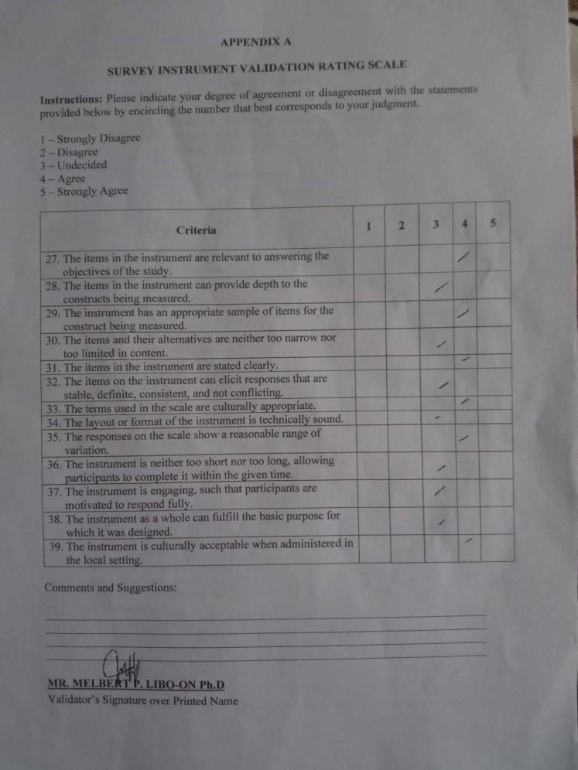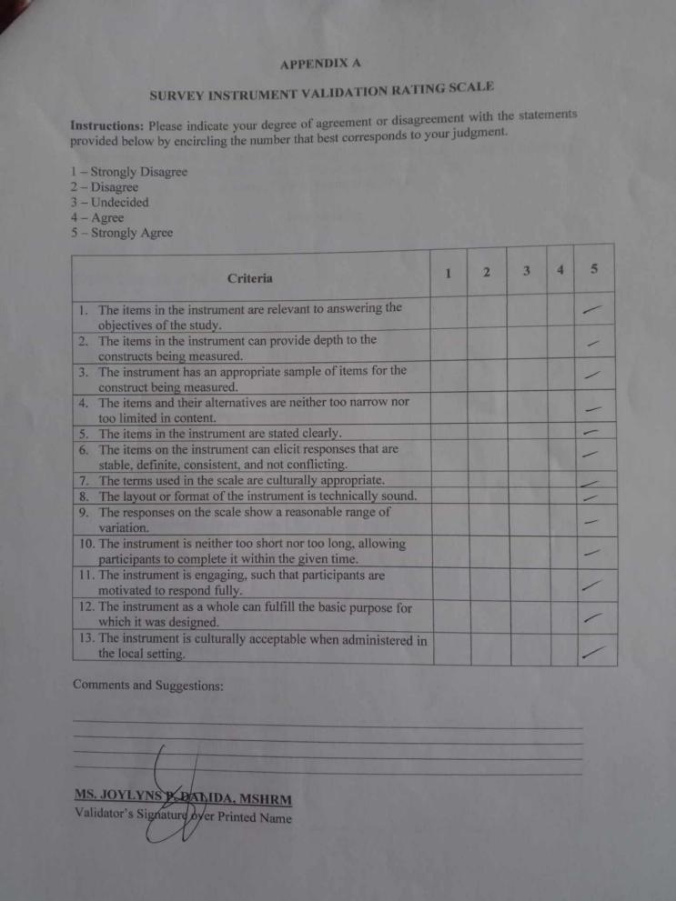

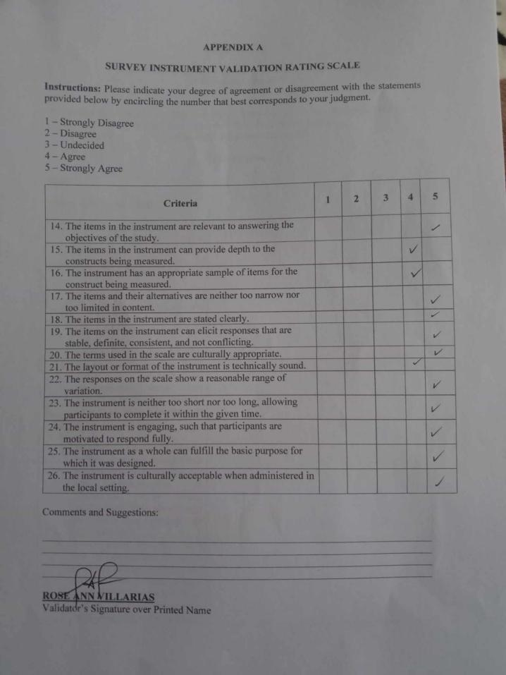

**References**

Braun, V. & Clarke, V. (2012). Thematic analysis. In H.Cooper, P. M. Camic, D. L. Long, A. T. Panter, D. Rindskopf, & K. J. Sher(Eds), APA handbook of research methods in psychology, Vol. 2: Researchdesigns: Quantitative, qualitative, neuropsychological, and biological (pp.57-71). Washington, DC: American Psychological Association.

Community perceptions on the benefits and challenges ... (2020). [https://www.tandfonline.com/doi/full/10.1080/0376835X.2020.1796599](https://www.tandfonline.com/doi/full/10.1080/0376835X.2020.1796599" \t "https://web.facebook.com/messages/e2ee/t/_blank)

Community Involvement in Natural Resource Management Leads to ... (2021). [https://carey.jhu.edu/articles/research-community-involvement-natural-resource-management-leads-less-overexploitation](https://carey.jhu.edu/articles/research-community-involvement-natural-resource-management-leads-less-overexploitation" \t "https://web.facebook.com/messages/e2ee/t/_blank)

Coyle, N., & Tickoo, R. (2017). Qualitative Research: What This Research Paradigm Has to Offer to the Understanding of Pain. *Pain Medicine*, *8*(3), 205–206. <https://doi.org/10.1111/j.1526-4637.2007.00303.x>

Creswell, John. (2013). Qualitative Inquiry & Research Design: Choosing Among Five Approaches. SAGE Publications. 11. <https://www.researchgate.net/publication/232577017_Qualitative_Inquiry_Research_Design_Choosing_Among_Five_Approaches>

Dar, S. A., & Kumar, A. (2022). Preservation of Natural Resources, Relocation Rehabilitation, and its Consequences. ECS Transactions, 107(1), 5969–5976. <https://doi.org/10.1149/10701.5969ecst>

Dechimo, A., & Buot, I. (2023). Plant and Other Forest Bioresource Utilization by Local Communities of Northern Negros Natural Park, Negros Island, Philippines. Philippine Journal of Science, 152(2). <https://doi.org/10.56899/152.02.09>

Gentles, S. J., Charles, C., Ploeg, J., & McKibbon, K. (2015). Sampling in qualitative research: Insights from an overview of the methods literature. The Qualitative Report, 20(11), 1772-1789. <https://doi.org/https://doi.org/10.46743/2160-3715/2015.2373>

Hennink, M. M., Kaiser, B. N., & Weber, M. B. (2019). What Influences Saturation? Estimating Sample Sizes in Focus Group Research. Qualitative Health Research. <https://doi.org/10.1177/1049732318821692>

Janashak Cadena, S. J. (2019). Qualitative research: interactions and experiences. *MedUNAB*, *22*(3), 292–293. <https://doi.org/10.29375/01237047.3746>

Kapania, S., Agnew, W., Eslami, M., Heidari, H., & Fox, S. (2024). “Simulacrum of Stories”: Examining Large Language Models as Qualitative Research Participants. *ArXiv (Cornell University)*. https://doi.org/10.48550/arxiv.2409.19430

Kvale, S., & Brinkmann, S. (2015). InterViews : learning the craft of qualitative research interviewing (Third edition). Sage Publications.

<https://uk.sagepub.com/en-gb/eur/interviews/book239402>

Lichtman, M. (2013). Qualitative Research in Education. 978-1-4129-9532-0.

Lijun, Ling & Ahmed, Elsadig. (2024). THE ROLE OF LOCAL COMMUNITIES IN SUSTAINABLE TOURISM DEVELOPMENT. 3. 1-17. <https://www.researchgate.net/publication/386292289_THE_ROLE_OF_LOCAL_COMMUNITIES_IN_SUSTAINABLE_TOURISM_DEVELOPMENT>

Local perceptions as a guide for the sustainable management of ... (2012). [https://pmc.ncbi.nlm.nih.gov/articles/PMC5029546/](https://pmc.ncbi.nlm.nih.gov/articles/PMC5029546/" \t "https://web.facebook.com/messages/e2ee/t/_blank)

Lu, C., & Wang, K. (2023). Natural resource conservation outpaces and climate change: Roles of reforestation, mineral extraction, and natural resources depletion. Resources Policy, 86, 104159. <https://doi.org/10.1016/j.resourpol.2023.104159>

Merlo, A. R., Goodman, A., McClenaghan, B. A., & Fritz, S. L. (2013). Participants’ Perspectives on the Feasibility of a Novel, Intensive, Task-Specific Intervention for Individuals With Chronic Stroke: A Qualitative Analysis. *Physical Therapy*, *93*(2), 147–157. https://doi.org/10.2522/ptj.20110147

Palinkas, L. A., Aarons, G. A., Horwitz, S. M., Chamberlain, P., Hurlburt, M., & Landsverk, J. (2015). Purposeful Sampling for Qualitative Data Collection and Analysis in Mixed Method Implementation Research. Administration and Policy in Mental Health and Mental Health Services Research, 42(5), 533–544 <https://doi.org/10.1007/s10488-013-0528-y>

Patton, M. Q. (2017). Sampling, Qualitative (Purposive). *The Blackwell Encyclopedia of Sociology*. https://doi.org/10.1002/9781405165518.wbeoss012

Rebuya, N. (2020). RESOURCE PROTECTION STRATEGIES TOWARDS SUSTAINABLE ECOTOURISM AND PROTECTED AREA CONSERVATION: A VISITORS’ EVALUATION IN BULUSAN VOLCANO NATURAL PARK, PHILIPPINES. International Journal of Tourism & Hospitality Reviews, 7(2), 12–19. <https://doi.org/10.18510/ijthr.2020.722>

Sharma, Manoj. (2019). A Review of Scenario and Status of Natural Resource Management Practices in Nepal Literature Review. 10. 79-84. 10.31080/ASAG.2019.03.0651.

Soni, Pavan. (2014). The Art of Case Study Research, by Robert Stake, 1995. <https://www.researchgate.net/publication/273635929_The_Art_of_Case_Study_Research_by_Robert_Stake_1995>

Shenton, A. K. (2004). Strategies for ensuring trustworthiness in qualitative research projects. Education for Information, 22(2), 63–75. https://doi.org/10.3233/efi-2004-2220.

<https://www.researchgate.net/publication/228708239_Strategies_for_Ensuring_Trustworthiness_in_Qualitative_Research_Projects>

The Role of Community in Natural Resource Conservation. (n.d.). [https://www.sciencedirect.com/science/article/pii/S0305750X98001612](https://www.sciencedirect.com/science/article/pii/S0305750X98001612" \t "https://web.facebook.com/messages/e2ee/t/_blank)

Trista Hollweck. (2024). Robert K. Yin. (2014). Case Study Research Design and Methods (5th ed.). Thousand Oaks, CA: Sage. 282 pages. University of Toronto Press Inc. (UTPress). <https://www.academia.edu/87937093/Robert_K_Yin_2014_Case_Study_Research_Design_and_Methods_5th_ed_Thousand_Oaks_CA_Sage_282_pages>

UNESCO. (2024, February 5). Conservation and sustainable use of biodiversity | UNESCO. Www.unesco.org. <https://www.unesco.org/en/biodiversity/conservation>

Untangling the Ethics of Incentives: Interview with Ruth W. Grant. (2015). [https://www.linkedin.com/pulse/untangling-ethics-incentives-interview-ruth-w-grant-jason-voss-cfa](https://www.linkedin.com/pulse/untangling-ethics-incentives-interview-ruth-w-grant-jason-voss-cfa" \t "https://web.facebook.com/messages/e2ee/t/_blank)